**Worksheet 1**

1. The “Revenue Trends” visualization shows that till a certain point in February, all three businesses performed in a similar way. Then, Upper West started collecting more revenues than the other two businesses.
2. B.B. Upper West Side and B.B. Brooklyn has more revenue on the weekends, whereas B.B. Lower West Side has more revenue on Tuesdays.
3. It is also seen that more the diversity of dishes (item count), more is the order count.

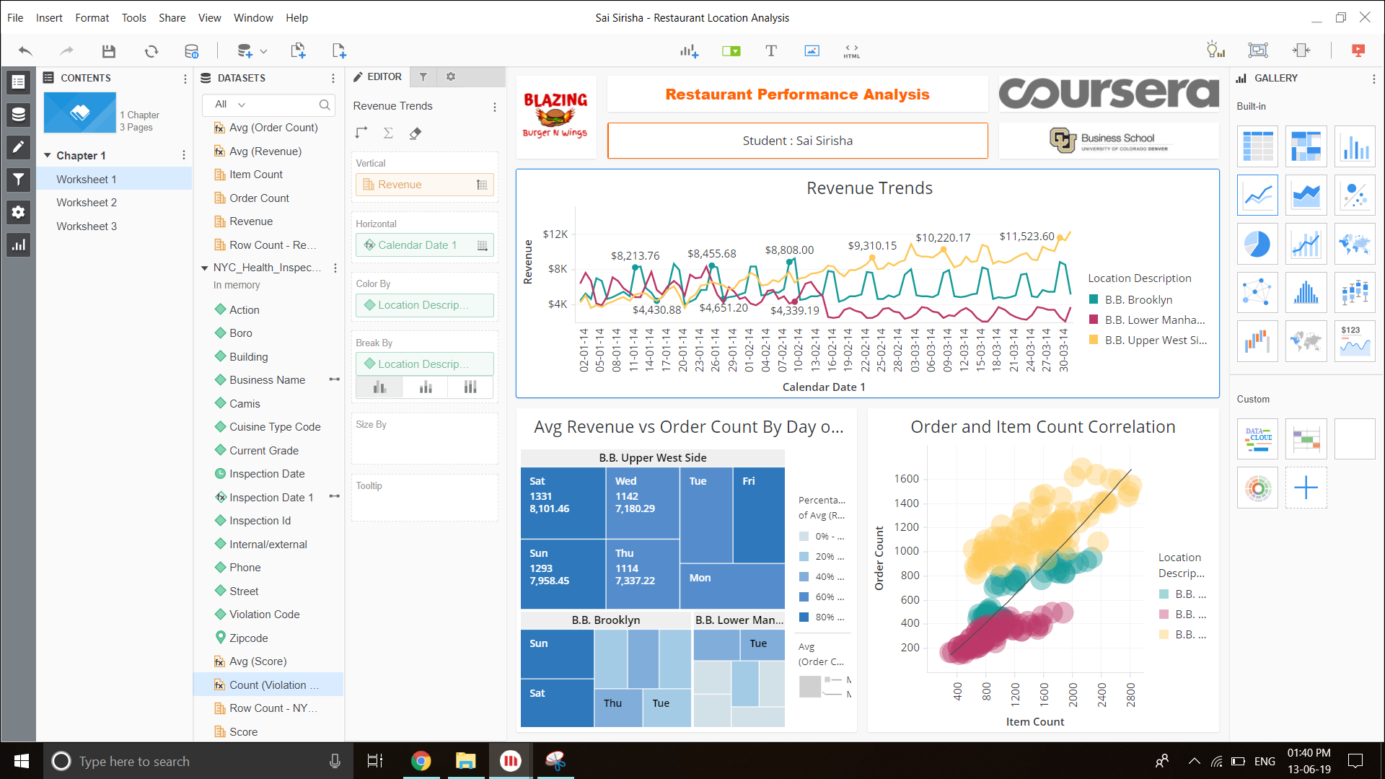

**Worksheet 2**

1. It is seen that the score inversely impacts the revenue of the business. The more the score, the better the quality of the business and hence, the more revenue.
2. B.B. Lower West is performing really poorly and hence, it has the lowest revenue.

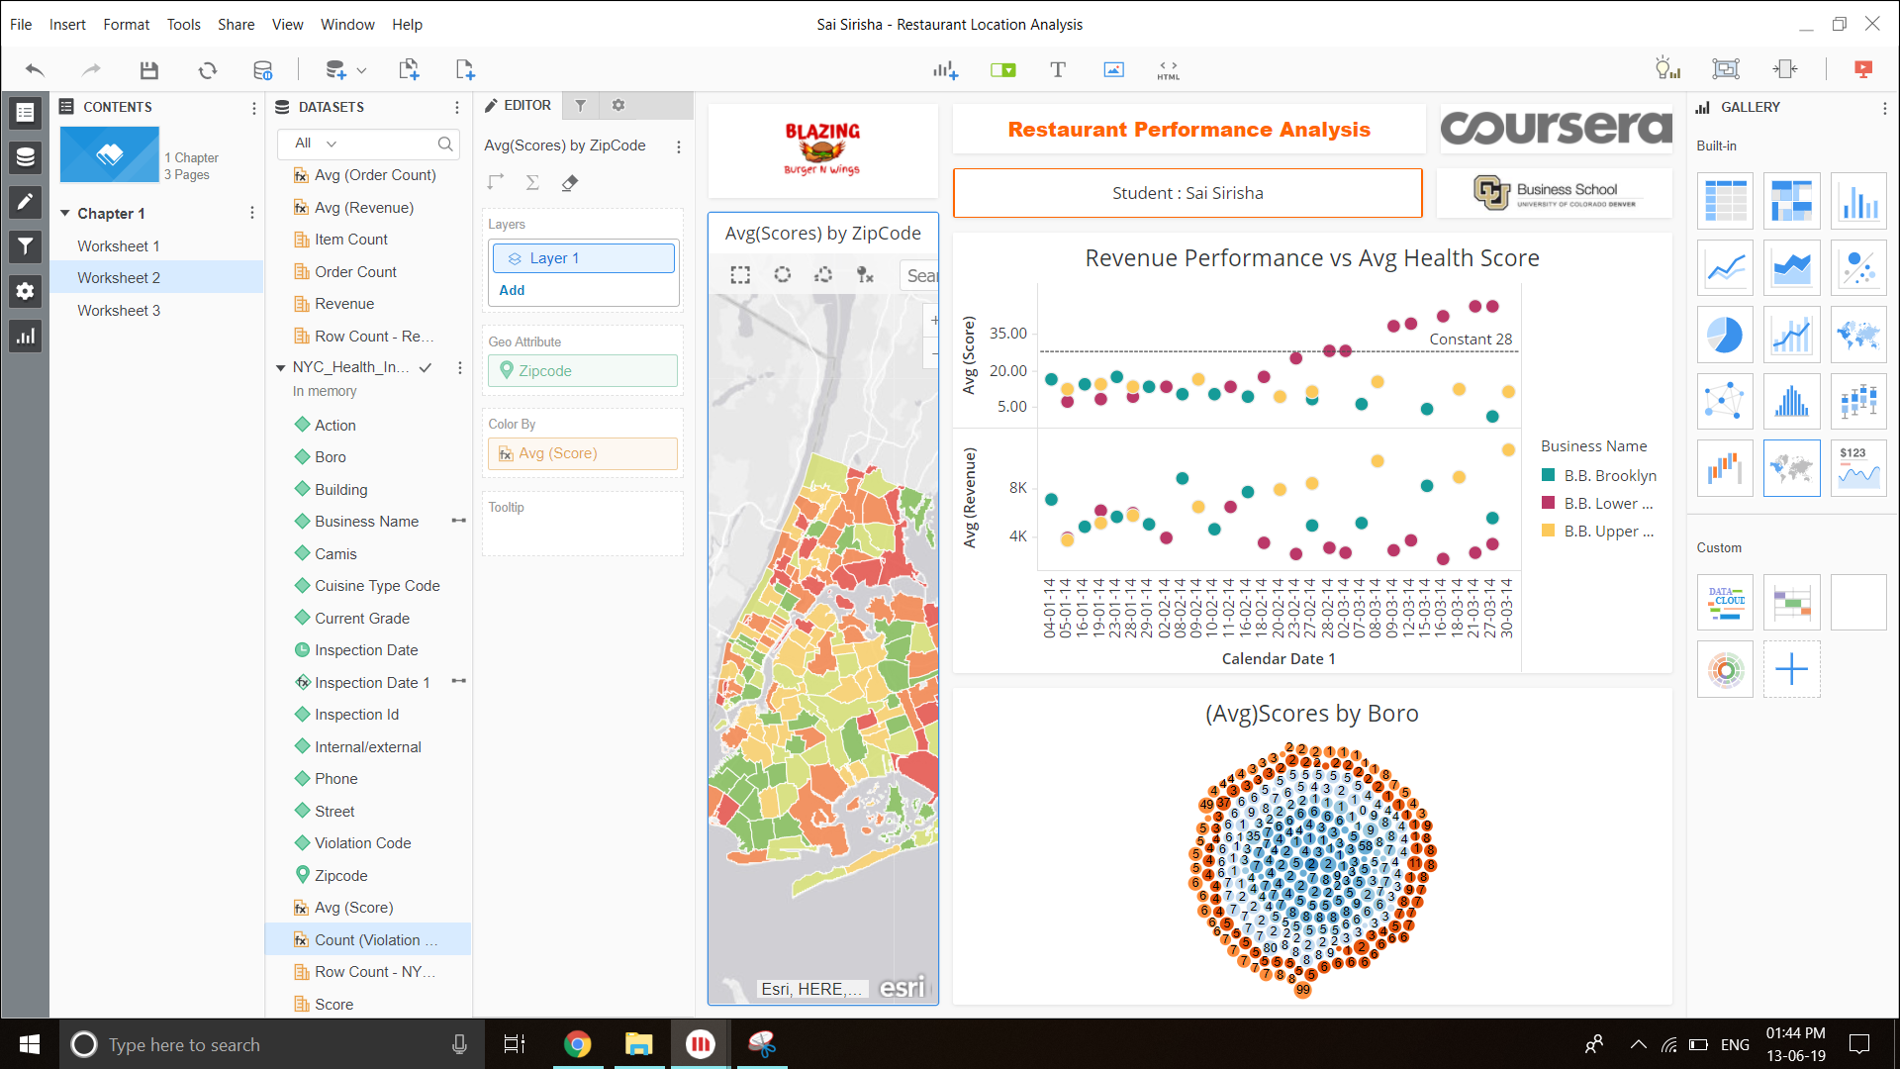

**Extra analysis**

The count of violations for each business will enable the inspector to penalize the businesses with a count of violations after a certain threshold. This will ensure that the quality of food is maintained.

Eg. According to the visualization, DUNKIN DONUTS must be penalised immediately as it has crossed the threshold of 300 violations.

